Formula 1 Race Pace, Tyre Degradation,
and Pit Strategy Analysis
An Interactive Power BI Dashboard — Project Walkthrough
Dataset: Ergast F1 Historical Database (Kaggle)
Tables used: races, drivers, results, lap_times, pit_stops
Tool: Microsoft Power BI (Power Query + Data Model + DAX + Report)

1. What Exactly Is This Project?
Formula 1 races are rarely won on raw speed alone. Two cars can be equally fast over one lap, but the race is decided by things that only show up over time: how fast a driver's tyres wear down, how well their team executes a pit stop, and whether they can overtake their way up the field from a bad grid position.
This project takes five years of real F1 data (2011 onward) and builds an interactive dashboard that lets us pick any Grand Prix and driver, and visually answer three questions:
- Race Pace vs. Degradation — how does a driver's lap time change as their tyres age within a stint, and where does performance suddenly fall off a cliff?
- Pit Stop Efficiency — how much time is gained or lost in the pit lane, and how does that compare across drivers/teams?
- Qualifying vs. Race Reality — does starting on pole guarantee a win, or do drivers regularly climb (or fall) through the field using race pace and strategy?
The end result is one interactive report page — pick a Year, a Grand Prix, and one or more Drivers from the slicers at the top, and every chart and number below updates instantly.

2. Why We Did Not Use Data From 1950 or 1996
The raw Ergast dataset technically goes all the way back to 1950. We deliberately chose not to use the full range. Here's the reasoning, step by step:
Cutoff | What's true at that point | Why we didn't use it
1950 | Full historical results exist | No lap-by-lap timing data at all. Pit stop timing barely existed as a concept. Can't analyze degradation or pit strategy — the whole point of the project — for 60+ years of the dataset.
1996 | Official per-lap timing begins | Coverage is real but patchy through the late 90s/2000s. Some drivers/races have gaps, so KPI cards would randomly show blank values depending which driver or year was picked — confusing for a demo.
2011 | Tyre-degradation era begins (Pirelli high-deg tyres) + lap/pit data is essentially complete from here on | Every driver in the slicer has usable data for every measure. It's also the era where tyre strategy actually became the deciding factor in races — which is exactly what this project is about.

In short: 2011 isn't an arbitrary number — it's the year Pirelli introduced deliberately high-degradation tyres to make races more strategic. That's the exact phenomenon this project is measuring, so it's also the most honest and most complete slice of the data to use.

3. Data Preparation — Power Query
Before any chart could be built, the five raw CSV files had to be cleaned, type-cast, and trimmed down to just the columns we need. All of this happens in Power Query Editor (Home → Transform Data), before the data ever reaches the model.

3.1 lap_times
Step | What we did & why
Remove columns | Dropped the text 'time' column — it duplicates 'milliseconds' but as unusable text.
Add column | LapSeconds = [milliseconds] / 1000 — converts raw milliseconds into a readable decimal (e.g. 91234 ms → 91.234 s).
Type casting | raceId, driverId, lap → Whole Number; LapSeconds → Decimal Number.
Remove errors | Removed any rows where milliseconds was blank or invalid.

3.2 pit_stops
Step | What we did & why
Remove columns | Dropped 'time' and 'duration' text columns, kept only 'milliseconds'.
Add column | PitSeconds = [milliseconds] / 1000.
Filter outliers | Kept only PitSeconds < 120 — anything longer is a red-flag stoppage or garage repair, not a normal pit stop, and would wreck the averages.

3.3 drivers
Step | What we did & why
Add column | Driver_Full_Name = [forename] & " " & [surname] — combines two columns into one readable name for slicers and legends.
Remove columns | Kept only driverId, code, Driver_Full_Name, nationality.
2011+ filter | Merged with the already-filtered 'results' table (Inner Join on driverId) so only drivers with at least one race in 2011+ remain in the list — this is why old drivers like Zanardi or Senna no longer appear in the slicer.

3.4 results
Step | What we did & why
Remove columns | Kept resultId, raceId, driverId, constructorId, grid, positionOrder, points, statusId.
Fix grid = 0 | Replaced grid value 0 (meaning 'started from pit lane') with 20, so the Net Positions Gained measure doesn't produce misleadingly huge numbers.
Type casting | grid, positionOrder → Whole Number; points → Decimal Number.
2011+ filter | Filtered races[year] >= 2011, then Inner-Joined results to races on raceId, so only rows belonging to 2011+ races remain.

3.5 races
Step | What we did & why
Remove columns | Kept raceId, year, round, name, date, circuitId.
Add column | Gp Label = Text.From([year]) & " " & [name] — used in the slicer so races read as e.g. '2019 British Grand Prix' instead of just 'British Grand Prix' repeated every year.
Year filter | Filtered year >= 2011 as the master cutoff — every other table was then joined against this filtered version.

4. Data Modeling — The Star Schema
Once cleaned, the tables were connected in the Model view. We used a star schema: two dimension tables (drivers, races) sit at the center and connect out to three fact tables (lap_times, pit_stops, results) that hold the actual event-level numbers.
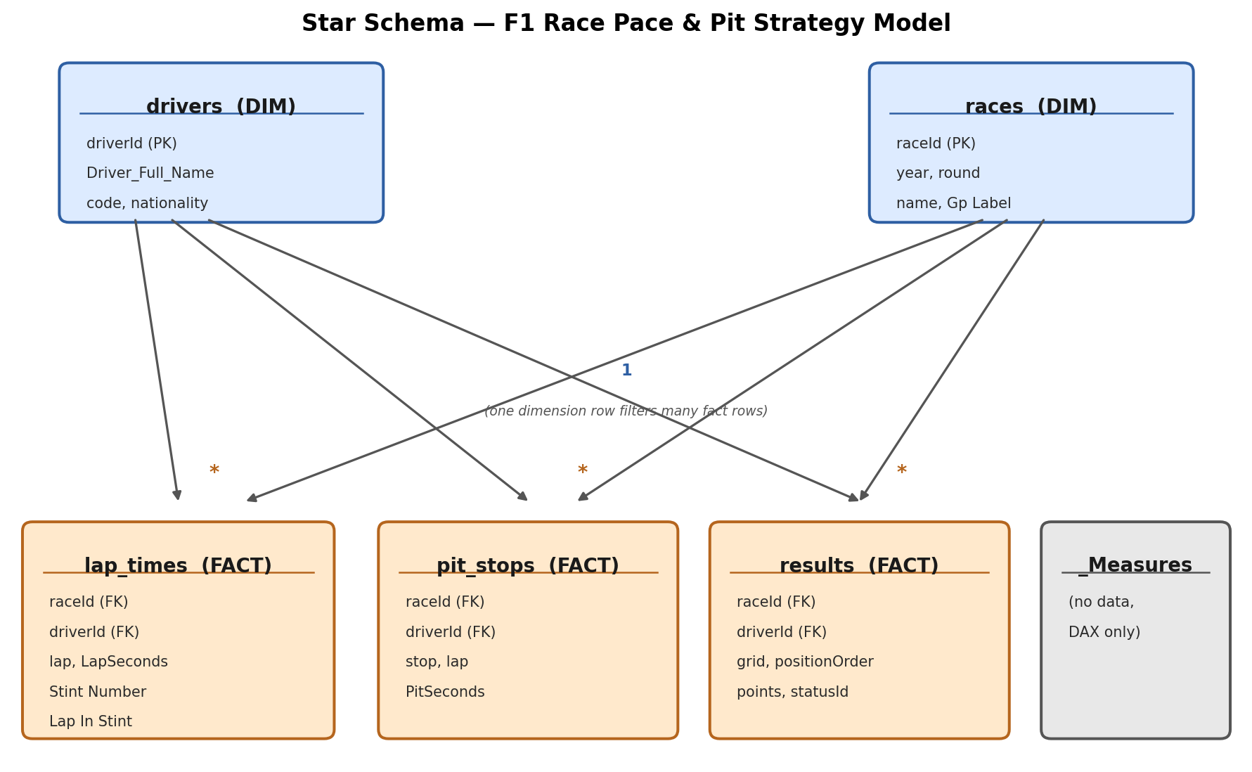
Figure 1 — Relationships are all One-to-Many (1:*), filtering from dimension → fact, single direction.
Why this structure matters: drivers and races each appear once per record (one row per driver, one row per race), but each of them has many related laps, many pit stops, and many results. Connecting it this way means picking one driver in a slicer automatically filters all three fact tables at once — that's what makes the whole dashboard respond instantly to slicer clicks.
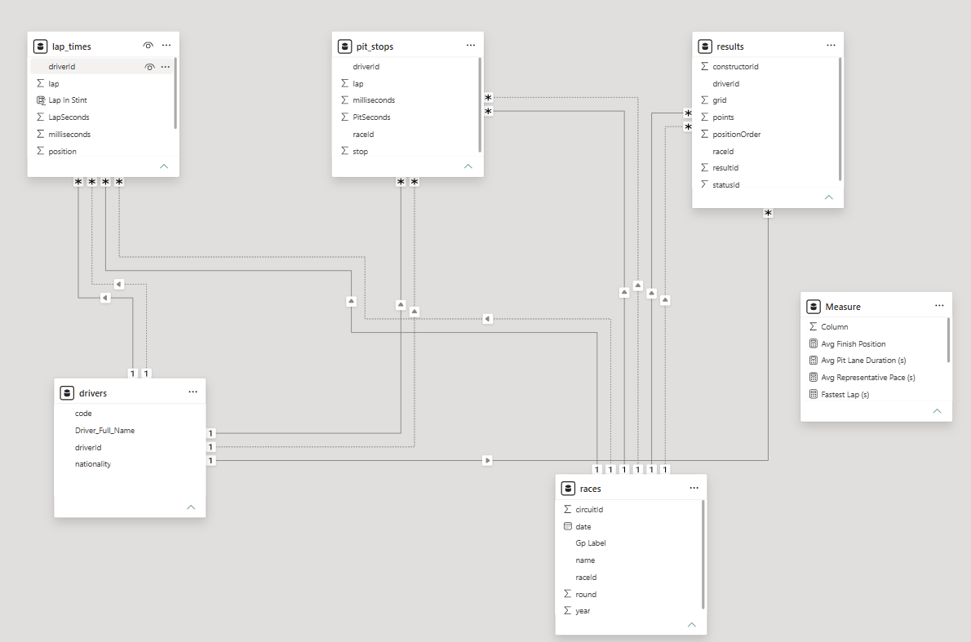

5. Two Special Calculated Columns
Raw lap numbers can't tell us tyre age — lap 30 could mean tyres that are 30 laps old, or 2 laps old if the driver just pitted. Two calculated columns on lap_times solve this:

Stint Number
Counts how many pit stops that driver has already made in that race before the current lap, then adds 1. Stint 1 = before any stop, Stint 2 = after the first stop, and so on.

Lap In Stint
Counts laps since the most recent pit stop, resetting to 1 every time the driver pits. This is the column plotted on the X-axis of the line chart — it's what makes three separate stints line up on top of each other instead of showing as one long sawtooth line.
Example: a driver who pits on laps 18 and 40 of a 58-lap race is in Stint 1 for laps 1–18, Stint 2 for laps 19–40 (Lap In Stint resets to 1 on lap 19), and Stint 3 for laps 41–58 (resets again on lap 41).

6. DAX Measures
Measures are the calculations that actually power the KPI cards and charts. All of ours live in one blank table called _Measures, kept separate from the data tables so they're easy to find.
Measure | How it's calculated | What it tells us
Fastest Lap (s) | MIN over all lap seconds | The single quickest lap set, in seconds.
Avg Representative Pace (s) | Average of laps within 107% of the fastest lap | "True" race pace, with Safety Car / pit / traffic laps filtered out.
Avg Pit Lane Duration (s) | AVERAGE of pit stop seconds | How long, on average, a driver spends stationary/transiting the pit lane.
Net Positions Gained | AVERAGEX of (grid − positionOrder) | Average places gained (+) or lost (−) per race, across all selected races.
Pace Consistency (StDev) | STDEV.P of representative-pace laps | How consistent a driver's pace is lap-to-lap; lower = more metronomic.

Why Avg Representative Pace uses a 107% cutoff
This is the standard rule used in real F1 timing — any lap slower than 107% of the fastest lap is excluded, because it's almost certainly a Safety Car lap, an in/out lap around a pit stop, or a driver stuck in traffic — not a genuine measure of race pace.

Why Net Positions Gained is an average, not a sum
Our first version summed grid-minus-finish across every race a driver had — which for a driver with 100+ races produced a huge, confusing negative number dominated by a handful of retirements (DNFs), not their actual racecraft. Averaging it per race turns it into a small, readable number like “−0.6” that's actually comparable across drivers.

7. The Report Page — Layout & Visuals
Everything lives on a single report page, arranged in four horizontal bands plus a dynamic title strip at the top:
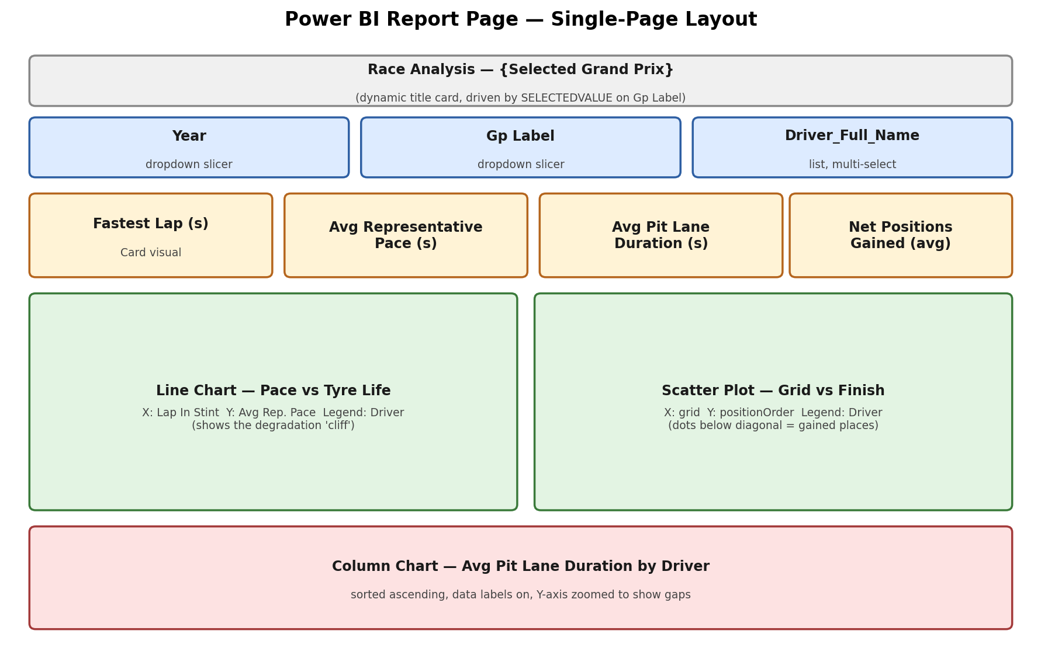
Figure 2 — Single-page dashboard layout.

7.1 Title strip
A Card visual driven by one measure: Report Title = "Race Analysis — " & SELECTEDVALUE('races'[Gp Label], "Select a Grand Prix"). It automatically updates to show whichever Grand Prix is currently selected.

7.2 Slicers
- Year — dropdown, filters everything below to one season.
- Gp Label — dropdown, filters to one specific race (e.g. “2019 British Grand Prix”).
- Driver_Full_Name — list, multi-select, so 2-4 drivers can be compared side by side.

7.3 KPI cards
Four Card visuals across the top: Fastest Lap, Avg Representative Pace, Avg Pit Lane Duration, and Net Positions Gained. These give an instant numeric summary before anyone even looks at the charts.

7.4 Line chart — the degradation story
X-axis: Lap In Stint. Y-axis: Avg Representative Pace (s). Legend: Driver. The Y-axis is inverted so a faster lap sits higher, making an upward slope on-screen mean the tyres are getting slower — visually, that's the degradation “cliff” the whole project is about.

7.5 Scatter plot — the overtaking story
X-axis: grid (starting position). Y-axis: positionOrder (finishing position). Legend: Driver. A dot below the diagonal means the driver finished better than they started — a genuine overtaking performance, not just a pole-to-win procession.

7.6 Column chart — pit crew performance
X-axis: Driver_Full_Name. Y-axis: Avg Pit Lane Duration (s), sorted ascending with data labels turned on and the Y-axis zoomed in, so that even a 1-2 second gap between pit crews is visible — in F1 terms, that gap regularly decides track position.

7.7 Polish features
- Dynamic title (above) reacts to the Gp Label slicer.
- Report-page tooltip — hovering any dot on the scatter plot pops up a mini line chart of that driver's whole race pace, without leaving the page.
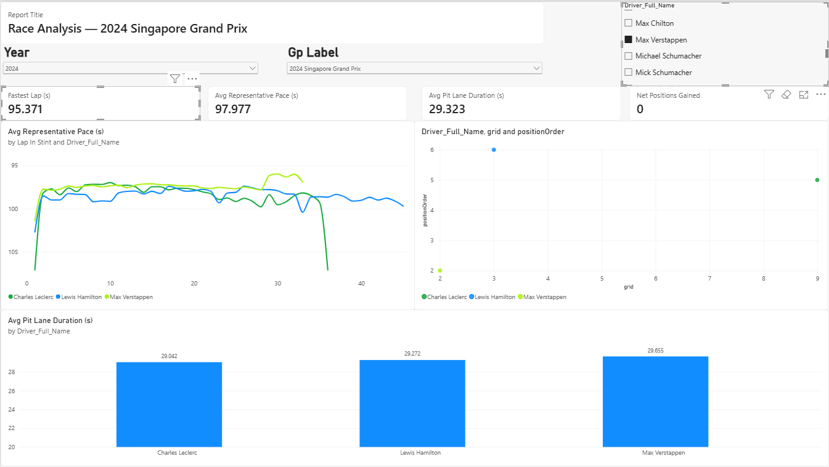
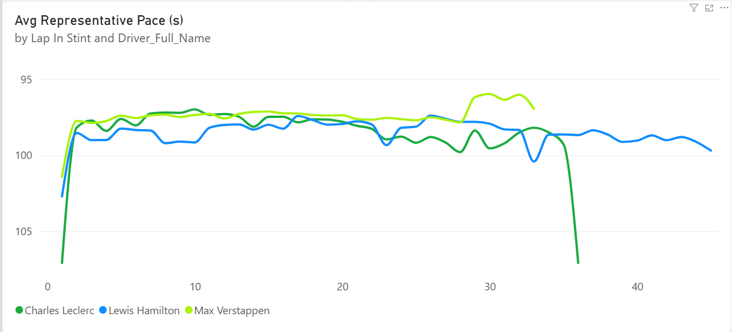

8. How to Present This to the Class
Suggested flow for a live walkthrough — pick one race with a strong story (e.g. a race with a lot of overtaking or a dramatic tyre failure) and narrate it in three beats:
- Open the dashboard, pick that Grand Prix in the slicer. Point at the scatter plot: “Pole position only converted to a win in about X% of races we have data for — starting first doesn't guarantee anything.”
- Point at the line chart: “Here's where a driver's tyres gave up — see this elbow around lap 35? That's the cliff. After this point every lap gets slower no matter how hard they push.”
- Point at the column chart: “And this is the actual pit lane time difference between crews — a gap this small, under 2 seconds, is often the difference between finishing P3 and finishing P5.”
- Close by explaining the 2011 cutoff decision and the 107% rule — these show the group made deliberate, defensible data-quality decisions, not just accepted the raw dataset as-is.
If your groupmates each want a piece to own: one person can walk through the Power Query / data cleaning story (Sections 2-3), one through the model + DAX (Sections 4-6), and one through the live dashboard demo (Section 7-8).

9. Presenting Live — Reading the Dashboard When a Year & GP Are Assigned
A teacher or examiner may assign a specific Year and Grand Prix on the spot, rather than letting you pick your own. Here's exactly what to do and what to say when that happens.

9.1 Set the slicers (10 seconds)
- Click the Year dropdown → pick the assigned year.
- Click the Gp Label dropdown → it now only shows races from that year → pick the assigned Grand Prix.
- Leave the Driver slicer on “All”, or tick 2–3 drivers if you've rehearsed a comparison — both approaches are covered below.
Everything else on the page updates automatically — the rest is just reading what's now on screen.

9.2 Reading the KPI cards (your opening line)
Card | How to read it
Fastest Lap (s) | The single fastest lap of the race. State it as-is: “the fastest lap of this race was X seconds.”
Avg Representative Pace (s) | Average genuine race pace. Compare to Fastest Lap: only 1-2s slower means very consistent pace; 3-4s+ slower means more traffic or degradation dragging the average down.
Avg Pit Lane Duration (s) | Average pit stop length. A clean modern stop is roughly 22–24s — a much higher number suggests a slow stop or two pulled the average up.
Net Positions Gained | Positive = drivers on average gained places (lots of overtaking / grid shake-up). Negative = drivers on average finished worse than they qualified (often DNFs pulling it down, or a processional race).

9.3 Reading the line chart (degradation story)
- Look at the shape of each line: flat or gently rising = tyres held up well; a sharp upward bend = the tyre “cliff” — performance collapsing within a lap or two.
- A line that drops back down and restarts from a low value marks a new stint (fresh tyres) — remember the X-axis is Lap In Stint, not race lap.
- With multiple drivers selected, whoever's line rises later/more gently managed tyres better.
Say: “This driver's pace stayed flat for the first ~15 laps, then climbs here — that's degradation kicking in. They pitted around here and pace reset to fresh-tyre level.” If the line looks mostly flat with no dramatic cliff, that's still a valid finding — say the tyre strategy for that race was conservative, and the race was decided more by pit strategy or grid position than by tyre wear. Don't force a “cliff” narrative the data doesn't show.

9.4 Reading the scatter plot (overtaking story)
- A dot below/left of the imaginary diagonal (finish number smaller than grid number) = the driver gained places.
- A dot above/right of the diagonal = the driver lost places.
- Dots clustered near the bottom-left = front-runners who started and finished near the top — a fairly processional race for them.
- A dot far to the right but low on the Y-axis (e.g. grid 15, finish 4) = a standout recovery drive — your best talking point if one exists.
Say: “This dot shows a driver who started P[X] but finished P[Y] — a genuine climb through the field.” If you selected “All” drivers, scan this chart first for the biggest outlier dot before you start talking — it's often the strongest story in the whole race.

9.5 Reading the column chart (pit crew comparison)
- Sorted ascending, so the leftmost bar is the fastest pit crew that race, for the drivers currently selected.
- Even a 1-2 second gap between the shortest and tallest bar is meaningful in F1 terms.
Say: “[Driver]'s team had the fastest average stop at X seconds, while [Driver]'s took X seconds longer — over a season that adds up to real championship points.”

9.6 One thing to prep in advance
Since you won't know the exact Year/GP until it's assigned, do one practice run beforehand with any random race — not to memorize numbers, but to build the habit of reading shapes and relative positions rather than exact values. The interpretation logic above (flat vs. rising line, above/below diagonal, tallest vs. shortest bar) holds true for any race — that's the point of an interactive dashboard instead of a static chart.

10. Field Reference — What Every Axis and Legend Means
A complete field-by-field map of the canvas, plus what each field actually represents and why it was placed there — useful if a teacher asks “why this field, on this axis?”

10.1 Quick map of every visual
Visual / Well | Field | Purpose
Year slicer | races[year] | Filters the whole page to one season.
Gp Label slicer | races[Gp Label] | Calculated column; filters to one specific race.
Driver slicer | drivers[Driver_Full_Name] | Calculated column; multi-select for comparison.
KPI Cards (x4) | _Measures[...] | Fastest Lap, Avg Representative Pace, Avg Pit Lane Duration, Net Positions Gained.
Line chart — X | lap_times[Lap In Stint] | Calculated column; laps since last pit stop.
Line chart — Y | _Measures[Avg Representative Pace (s)] | 107%-filtered average lap time.
Line chart — Legend | drivers[Driver_Full_Name] | One colored line per driver.
Scatter — X | results[grid] | Starting grid position.
Scatter — Y | results[positionOrder] | Finishing position.
Scatter — Legend | drivers[Driver_Full_Name] | Colors/labels each dot by driver.
Column — X | drivers[Driver_Full_Name] | One bar per driver.
Column — Y | _Measures[Avg Pit Lane Duration (s)] | Average pit stop length for that driver.
Title card | _Measures[Report Title] | SELECTEDVALUE on Gp Label, reacts to slicer choice.
Tooltip page — X/Y | lap_times[Lap In Stint] / Avg Representative Pace (s) | Mini pace chart shown on hover over a scatter dot.

10.2 Row 3 (Left) — Line Chart: Pace vs. Tyre Life
X-axis — Lap In Stint: a calculated column, not a raw field — counts laps since the driver's last pit stop, resetting to 1 every time they pit. Purpose: isolates “tyre age” from “race lap number.” Using the raw lap column instead would smash three different stints on three different tyre sets onto one continuous axis, producing a messy sawtooth instead of a clean degradation pattern. Putting Lap In Stint here means every stint starts fresh at 1, making all stints — and all drivers' stints — directly comparable.
Y-axis — Avg Representative Pace (s): a measure — average lap time in seconds after excluding laps slower than 107% of the fastest lap. Purpose: raw lap time would include Safety Car laps, pit in/out laps, and traffic-affected laps, none of which reflect tyre wear, and would make the line jump around unpredictably. Filtering to representative pace means the line only reflects genuine tyre-driven performance change.
Legend — Driver_Full_Name: splits the single line into one differently-colored line per driver. Purpose: without it, Power BI would blend every selected driver's laps into one averaged line, losing the ability to compare who degraded faster than whom.
What the shape means: a rising line = tyre performance dropping off through the stint. A flat line = tyres holding up well. A sudden steep upward bend = the “cliff,” where the tyre's performance collapses within a lap or two rather than declining gradually.

10.3 Row 3 (Right) — Scatter Plot: Grid vs. Finish
X-axis — grid: raw column from results — the driver's starting position (1 = pole). Purpose: this is “where they started,” the input side of the story.
Y-axis — positionOrder: raw column from results — the driver's actual finishing position (1 = race winner). Purpose: this is “where they ended up,” the output side. Together, X and Y form a before/after pair for every dot.
Legend — Driver_Full_Name: colors each dot by driver and lets you hover/read which dot belongs to whom. Purpose: without it, dots would be anonymous — fine for the overall shape of the race, useless for pointing at a specific driver's result.
What a dot's position means: below/left of the diagonal (e.g. grid 12, finish 5) = the driver gained places — good race pace or strategy. Above/right of the diagonal (e.g. grid 3, finish 14) = the driver lost places — likely a bad start, a penalty, or a mechanical failure. Right on/near the diagonal = they finished roughly where they started, a processional result for that driver.

10.4 Row 4 — Column Chart: Pit Crew Comparison
X-axis — Driver_Full_Name: categorical axis — one bar per driver currently selected in the slicer. Purpose: this is what you're comparing across — it turns the chart into a side-by-side comparison rather than a single number.
Y-axis — Avg Pit Lane Duration (s): a measure — the average of that driver's pit stop durations, in seconds, across all their stops in the currently filtered races. Purpose: this is the thing being measured for each driver — how efficiently their crew executes a stop, on average.
No legend is needed here — each bar already is one driver by virtue of the X-axis, so there's nothing extra to color-code.
What the bar height means: a shorter bar = a faster pit crew, since the chart is sorted ascending — meaning less time lost in the pit lane, which directly translates to better track position after the stop. A noticeably taller bar flags either a genuinely slower crew, or possibly one slow outlier stop (a bad wheel nut, a red flag stop) dragging their average up — worth mentioning as a caveat if asked why one driver's bar looks unusually tall.

